**28. Design DFA using simulator to accept the string the end with ab over set {a,b) W= abbaabab**

**AIM:** To design DFA using simulator to accept the string the end with ab over set {a,b) W= abbaabab

**TRANSITION DIAGRAM:**

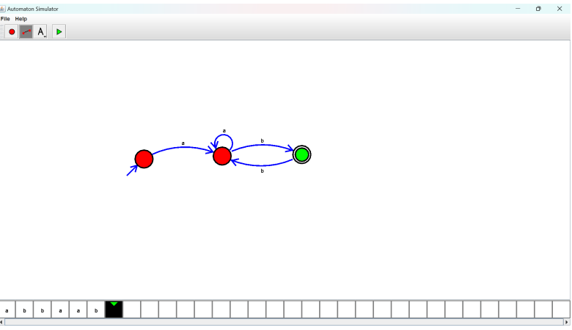

**RESULT:** Hence designing DFA using a simulator to accept the string the end with ab